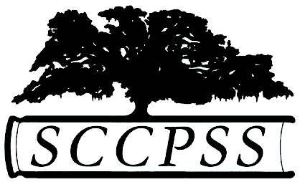
Savannah-Chatham County Public School System

Family Feedback Form

School: ____________________________________

Meeting Title: Family Forum - Training Staff

Date: _____________ Meeting Time: ____________

As a parent or family member who has a child that attends this school, are there any areas you feel we need to specifically training staff on in dealing with families?

What do you feel are barriers for parents/families when meeting with school staff?

As a staff, what can we do to make you feel more empowered as an active participant in your child’s education?

How can we as a school do a better job of partnering with families for student academic success?

Would you be willing to assist with staff trainings on collaborating with parents/families?
If yes, please list your name and an email address or phone number.

Thank you!! We appreciate your feedback.

